Project in Computer Networks

Smart Door Access System

Contents
1 Abstract 3
2 Introduction 4
2.1 General Requirements 4
2.2 Client Requirements and Server Requirements 4
3 Scenarios 6
3.1 Student Enters the Lab 6
3.2 Server Updates Client's List 7
4 Security 8
4.1 Integrity, Authentication and Privacy 8
4.2 Usage Implications 8
4.3 User Interface Security 8
5 Logging 9
6 Database 9
7 Design 11
7.1 Multithreading 11
7.1.1 Client threads: 11
7.1.2 Server Threads 11
7.2 Concurrency 11
7.3 Design Patterns 11
8 Administration 12
8.1 Client Configuration Files 12
8.2 Server Configuration Files 14
8.3 Server Administration 14
8.3.1 Login Screen 15
8.3.2 Groups 15
8.3.3 Users 16
8.3.4 Logs 16
8.3.5 Doors 17
8.3.6 Settings 17
9 User Guide 18
9.1 Installing a Standalone Client 18
9.1.1 Configuring Client for Windows NT 18
9.1.2 Configuring Client for Linux 18
9.1.2 Configuring Parallel Port BIOS Settings 19
9.1.3 Running the Client 19
9.2 Installing the Server 19
9.2.1 Installing XAMPP for Windows 19
9.2.2 Configuring Other or Remote MySQL Server 20
9.2.3 Installing Door Project Server Program 20
9.2.4 Configuring the Server Program 20
9.2.5 Running the Client in Normal Mode 20
9.2.6 Creating Certificates 20
10 Door Lock Circuit 21
11 References 21
12 Thanks Error! Bookmark not defined.

1 Abstract

This project solves the problem of entrance control to facilities such as the Computer Networks laboratory. Our system manages card readers, attached to each door to the lab, and opens the doors for registered students. There is a server computer that holds the lists of doors and students; it has a graphical interface that can be accessed over the network. The system supports multiple doors, multiple students and student groups.

Our system uses the following commonly available devices:
- At least one regular PC with Linux or Windows NT family operating system and JRE.
- Simple card readers connected to the computer, that send the card numbers to stdin.
- Optional: Network connection to administer the doors by remote
- Optional: Server computer with MySQL server and web server. Administers all the clients.

One piece of special hardware is required for each door: an electronically controlled lock that connects to the PC’s LPT interface. The lab staff developed this hardware for our project. The lock is activated by voltage between two pins in the LPT interface.

The programming language we used is Java 6.0. IDEs: Eclipse, Net Beans 5.5
Software needed to use our system: JRE 6.0, MySQL database, web server.

2 Introduction

2.1 General Requirements
- Support multiple doors
  - There’s a PC near each door that has a card reader, a lock controller and an internet connection. This computer is called a DoorProj Client computer.
  - Central DoorProj Server computer that communicates with all Clients.
- Reliability
  - In case of electricity blackout, after the electricity is restored, all computers boot and run our programs automatically, so the system continues working unattended.
  - Network unavailability: if the connection between clients and server can’t be established, the system keeps on working and logging entrances. The server and the clients will exchange the stored information when the network connection is restored.
- Security
  - All communications between the computers use SSL for encryption and authentication.
  - Clients must have a password to authenticate with the server.

2.2 Client Requirements and Server Requirements
- DoorProj Server computer
  - Holds list of students that are allowed to enter the lab in MySQL database
    - The database can run on another computer, but it's more efficient if it’s the same computer that runs MySQL and our DoorProj Server program.
  - Has web interface for the administrator. The interface is a Java Applet. It allows adding and removing clients and students, searching logs, etc.
    - The web interface communicates with the database and they must be on one computer. The web interface doesn’t communicate with the DoorProj Server program.
    - Allows grouping of students for more efficient administration.
  - Communicates with all the DoorProj Clients:
    - Connects to each client and transmits the list of allowed students every few minutes
    - Listens for reports from the clients.
  - Logs entrances to the lab
    - Clients send the server logs of entrances, and the server saves them in its database. This event is triggered either by server's request or by a client, when a user enters the door. A client can be set to report entrances immediately, or to store a log of entrances until the server initiates a connection.
- DoorProj Client computers that are located near each door
  - Every client computer is connected to a card reader and an electric door lock
  - Communicate with the server over TCP/IP (with SSL)
    - Must provide password for authentication
  - Can work during network unavailability
    - Has its own list of allowed students.
    - Stores log of events in a temporary file, and sends it later to the server
  - Standalone Mode – Can work completely by itself (but management is inconvenient)
  - Client program is installed on a Linux computer, and runs at startup

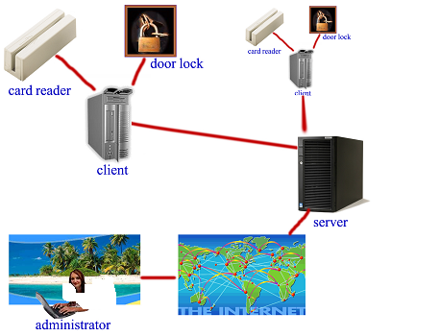
Figure 2.1: Module diagram

3 Scenarios

3.1 Student Enters the Lab

Trigger: A student passes his student card through the card reader. The number of the card is read by the client computer from STDIN as if someone entered the number on the keyboard; that's how simple card readers work. The client computer checks with its own records whether this student is allowed to enter. If positive, it opens the door lock for a few seconds; this event is saved to client’s temporary log. Then, if the client is set to auto-report, it runs the following protocol.
Summary: Client reports to the server about the entrance, and receives a new student list if needed. If the protocol fails for any reason, the client computer keeps the log file so the event can be reported later.

client
server
card reader
lock
Student id
unlock
1. Client Number
2. Client Password
3. Client Log
4. “ok” or “newlist”
5. Students List
6. “ok”

- Client sends it’s ClientID to the Server. Server checks whether this client’s IP matches the IP stored within its records (in the database), and replies with an error message that says “Wrong IP” if it doesn’t match.
- Client sends its password to the server. Server replies with “wrongpass” error message if it’s incorrect.
- Client sends its log of entrances (including the one that triggered this protocol). Server saves the log events to its database.
- Server checks when the last time a list of students was sent to the client. If it’s time to send a new list (the timeout can be changed in server settings), Server sends message “newlist”, if it’s not, Server sends “ok” and the protocol is finished. Client truncates its temporary log.
- Server generates a list of students that are allowed to enter the door and sends it.
- Client replies with “ok” and the server updates the time of last client student list update in its database

3.2 Server Updates Client's List
client
server
2. Client Password
1. “hello, 4”
accumulated log
students list
“OK”
Trigger: Timer, with timeout that can be changed in the server’s GUI.

Summary: The Server connects to each Client and sends a new list of students that are allowed to enter the lab. If the client has a temporary log of entrances, it sends it to the server.

- Server sends “hello, NUM”, where NUM is the door number (ClientID)
- Client replies with its password, or error message in case his ID is different
- Server sends new list of allowed students, Client writes it to the normal student list file and starts to use it immediately
- Client sends log of events (can be empty)
- Server replies with “ok” message, stores the log in its database and updates the last update time for this client in the database. Client truncates its temporary log of events.

4 Security

4.1 Integrity, Authentication and Privacy

All communications in our project use java's SSLSocket class. This class provides:
- Integrity Protection – the data passed between the computers can't be altered by an attacker
- Authentication – an attacker can't pretend to be the server or a client by using IP spoofing or any other attack, including "man in the middle"
- Privacy – all data sent over the network is encrypted
Each client has a password that it must send to the server on each connection, whether it was initiated by the client or by the server.

4.2 Usage Implications

SSL uses asymmetric encryption algorithm (like RSA), so every computer in our network must produce a key pair (private and public keys) and publish its public key in a binary file called Certificate. The certificate should be transmitted to other computers over an authenticated channel; otherwise an attacker can alter it, and compromise the security provided by SSL. Therefore the system administrator should produce certificates on all the computers and transmit them to the other computers, preferably on a physical medium like Disk. Since clients don't communicate with each other he will only have to introduce the server to every client and vice versa. It is also possible to use one key pair for all clients, so the server will use only one client certificate for all clients. Every Client has a password so they can't lie about their identity.

4.3 User Interface Security

The server's user interface is a java applet; it can be accessed from any computer connected to the internet. The applet asks you for the password to SQL server and connects to it.
The web server that stores the applet should always use SSL mode and have a valid SSL certificate. Otherwise an attacker can build a web site similar to the one that stores the applet and use DNS poisoning to make your DNS server send you to his fake site instead of the real one, and then he'll be able to put an applet in it that asks you for the database password and reveals it to him. This can be prevented by accessing the site from a local network by its IP address or using a signed SSL certificate for the web server.

5 Logging

The system logs any attempt to enter the lab, whether the door was unlocked or not. The client computer saves all log events to a file on its hard drive immediately after the event occurs. The fields in the log file are as follows: card number, timestamp, allowed (boolean - whether the door opened for the student). If the client is set to auto-report, it tries to connect to the server and transmit the log file. Anyway, when the server initiates a connection to the client, the client transmits the log file. The server saves the events from the log file to its database. Clocks on all the computers should be set to the correct time in order for the logs to show right timestamps, because the server must trust the clients to write a correct timestamp on each event in the log file.

6 Database
The next chart shows the table diagram of the server's database.
doors
doorNum
doorName
doorLastListUpdate
doorLastLogRecieved
doorIP
doorMAC
doorPassword
groups
groupNum
groupName
groups_to_doors
groupNum
doorNum

users
userID
userfName
userlName
userValid
userEmail
userPhone
userDescription
users_to_doors
userID
doorNum
users_to_groups
userID
groupNum
serversettings
name
value
description
log
time
ID
door
allowed

Please see next page for explanations about each table.
doors information about the client computers
doorNum door number - primary key for this table
doorName string – name of the door
doorLastListUpdate when did the server send a list of allowed students for the last time
doorLastLogRecieved when did the client send a log of events for the last time
doorIP IP address of the client computer
doorMAC MAC address of the client computer's network card (not used)
doorPassword password that the client must provide on every connection

groups information about the student groups
groupNum group number – primary key
groupName group name – string

groups_to_doors connector table between groups and doors – which groups are allowed to enter which doors
groupNum number of the group
doorNum number of the door

users information about the users – students who are registered to the system
userID number of the user's ID card or any other card he uses to enter the lab
userfName first name
userlName last name
userValid boolean – whether the user is active
userEmail email address
userPhone phone number
userDescription string

users_to_groups connector table – which users are registered to which groups
userID user card number
groupNum group number

users_to_doors connector table – which users are allowed to enter which doors
userID user card number
doorNum door number

log log of events – every card reading is an event
time date and time of the event
ID user card number
door door number
allowed boolean – whether the student was allowed to enter

serversettings server program settings – can be changed from the GUI
name setting name
value setting value
description string – not used

7 Design

7.1 Multithreading
Both the client and server use multithreading.

7.1.1 Client threads:
1. Card reading thread: reads student card numbers from the card reader; writes to the log of entrances and creates a Reporter thread.
2. TCP listening thread: listens for connections from the server, transmits entrances log and receives a new list of allowed students.
3. Reporter thread: connects to the server via TCP, transmits a log of entrances and receives a new student list

7.1.2 Server Threads
1. TCP listener: listens for connection from the clients, receives logs and sends lists of allowed students.
2. List sender: sends new lists of allowed students to the clients every few minutes.

7.2 Concurrency
The client's threads use common data structures. For example the card reading thread and the TPC listening thread both use the list of allowed students. We created synchronized classes for the list of students and the temporary client log. Also, both classes can be serialized.

7.3 Design Patterns
We used the following design patterns:
Factory
We used a socket factory to create SSL sockets – thus we were the users of the pattern, we didn't implement it.

Multilayer code Architecture
We used two layers in the applet and the server: the DAL (Data Access Layer) and PL (Presentation Layer, all logic and data display).

Composition
All applet components were created as different, not related components, and composed together in the common panel.

8 Administration

8.1 Client Configuration Files
The client's configuration files are located in its /data directory.
ClientKeystore.jks
This is the storage file for SSL keys. It holds the clients private key. The file in encrypted and the encryption password is saved in the config.ini file.
clientlog.set
A binary file that saves the log of entrances to the lab in case the client can't report to the server. This file is periodically transmitted to the server and the server stores the data in its database.
server.cer
Server's SSL certificate. This file is used to authenticate the server and encrypt data. It should be created on the server and transmitted to the client in a secure way. Do not transmit this file over a non-authenticated link, because an attacker might replace your file and send his certificate instead, so later he can decrypt all messages and forge the server's signature.
students.txt
A list of students that are allowed to enter this door. This list is transmitted to the client by the server every few minutes.
students_standalone.txt
This file is similar to the one above, but for working in standalone mode: without communicating with the server. You can edit this file in notepad, just add or remove card numbers. All changes made to this file take effect immediately after saving it. You can use the same file for standalone mode and normal mode, but note that it will be overwritten when a new list will is received from the server.

Config.ini
Client computers can be configured by editing this file. The client program needs to be restarted for the changes to take effect.
The configuration parameters and their meaning:
ServerIP=127.0.0.1 | IP address of the server.
ServerPort=1234 | Port number on which the server listens to client connections
ClientPassword=asdf | Client password. The server requires the clients to provide the password on every connection.
ClientId=2 | Serial number of the client. Must be unique.
ClientName=Door to room 352 | Name of the client - optional.
TextLog=off | Tells the client whether it should write a textual log file to its hard drive, for debugging purposes. The log files never exceed 4 kb.
TextLogFileName=data/Client.log | File name for text log of entrances.
TextLogFileNameUpdateListener= data/Updates.log | File name for text log of connection from the server.
StandaloneMode=off | Work in standalone mode without the server (on/off)
StandaloneModeStudentsFile= data/students_standalone.txt | File of allowed students in case the client works in standalone mode
NormalModeStudentsFile= data/students.txt | File of allowed students in case the client works in normal mode
BinaryLogFile=data/clientlog.set | Binary log of entrances that is to be sent to the server
AutoSendLog=on | Report to the server after each entrance (on/off)
ListenForListUpdatesOnPort=1235 | Client listens on this port for connections from the server.
WaitOnOpened=5000 | How much time the door lock stays open after an allowed user passed his card. In milliseconds.
LptPortAddressBase=3bc | LPT port address base. For communicating with the door lock control
KeyStorePass | Password to decrypt the local SSL keystore file.
ClientCertPass | Password for the client's certificate

8.2 Server Configuration Files
The server's configuration files are located in its /data directory.
ServerKeystore.jks
This is the storage file for SSL keys. It holds the server's private key. The file in encrypted and the encryption password is saved in the config.ini file.
client.cer
Client's SSL certificate. This file is used to authenticate the client and encrypt data. In case of multiple clients add more certificate files to this directory, the server program will read all the *.cer files in this directory

config.ini
Configuration file for the server. Contains only settings that can't be controlled from the GUI

sqlconnectionstring=  jdbc:mysql://127.0.0.1:3306/doorproj | SQL connection string. Replace "127.0.0.1" with the IP of the SQL server. Replace "doorproj" with your database name. 3306 is the default port of SQL servers
sqluser=doorproj | username for the SQL server
sqlpass=123456 | password for the SQL server
keystorePass=serverstore417341234 | Password to decrypt the server's SSL keystore file.
certificatePass=server29827 | Password for the server's certificate

8.3 Server Administration

The user interface for routine work is the server's web interface. It is implemented as a Java Applet so it can be accessed from any computer with a web browser and Java 6.0. All changes in the database take effect immediately, there's no need to restart the server program. Note that if you add new students to a client's list, it will take some time for their numbers to propagate to the client. They won't be able to enter immediately, but only after the server transmits a new list of allowed students to the client. The transmission can be initiated either by the server or by the client, see next chapter: Protocols for Client-Server Communications

8.3.1 Login Screen  This is the first screen you will see after loading the applet. Please enter the username and password for the MySQL server.  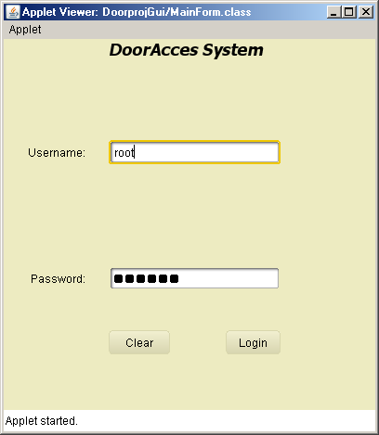  If the login procedure fails, check your password and verify that the SQL server accept connections from remote hosts. | 8.3.2 Groups  Add groups by clicking on the Add button.  Edit and remove groups by right-clicking on the group name in the groups' tree. Edit and remove users in the same manner.  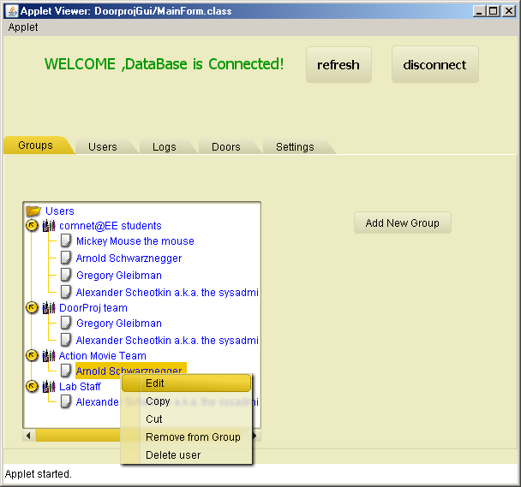  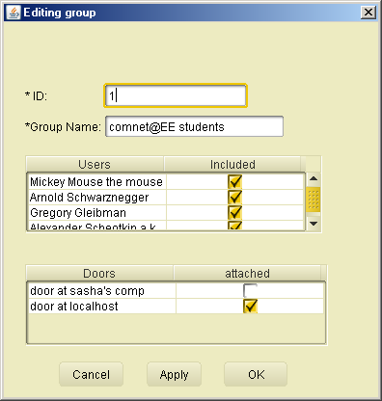
8.3.3 Users  Users tab allows adding, removing and editing users. The UserID is the card number. Right-click on a user to change his settings.  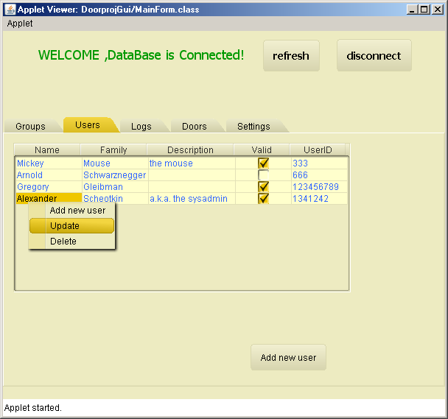  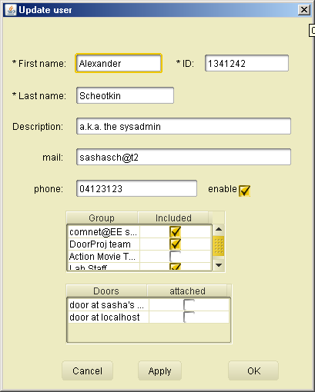  This screen allows you to add the user to groups and to allow him enter specific doors. | 8.3.4 Logs  This tab shows the logs of entrances. You can search the logs by door number and date  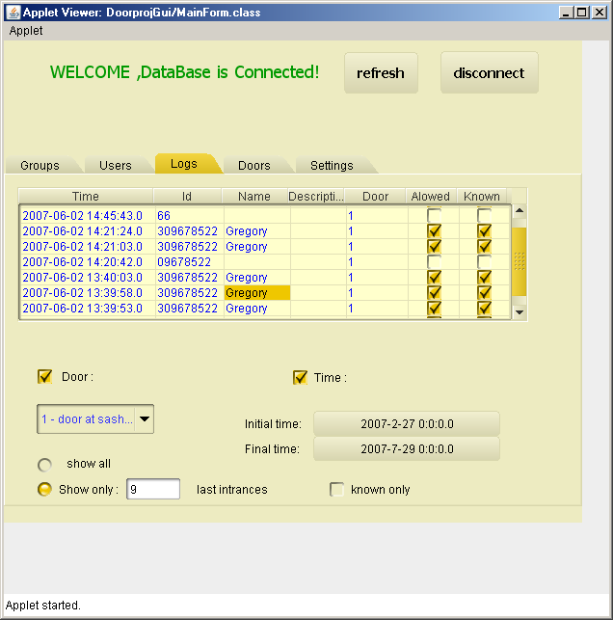  Allowed – the door opened for the students  Known – whether the student is registered to the system
8.3.5 Doors  Edit door settings, add groups and users to a door  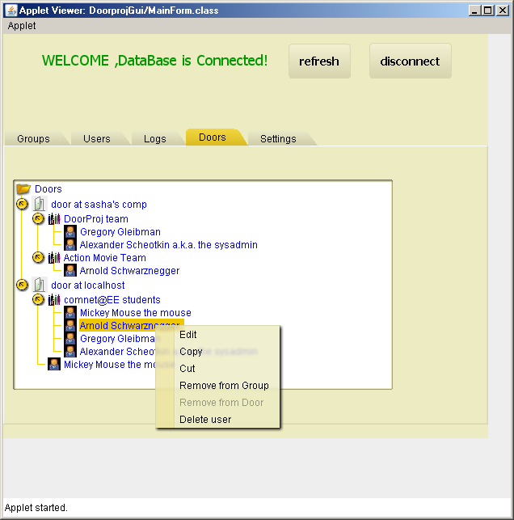 | 8.3.6 Settings  Change settings for the server program  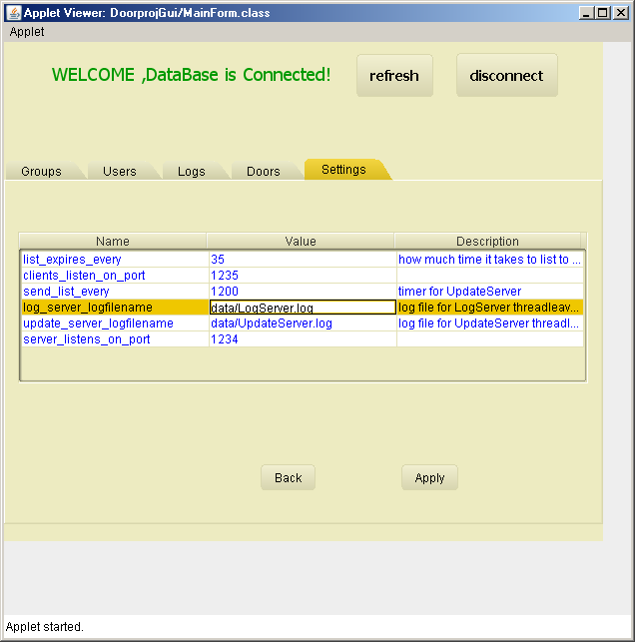  list_expires_every (seconds) – timeout for list of allowed students to get expired. If the list is expired and the door connects to the server, the server sends a new list.  clients_listen_on_port – port number to connect to the clients  send_list_every (seconds) – time between server list update cycles  log_server_logfilename – log for debugging  update_server_logfilename – log for debugging  server_listens_on_port – port number to listen for incoming client connections

9 User Guide
Please verify that Java JRE 6.0 or later is installed on all the relevant computers before proceeding.

9.1 Installing a Standalone Client
To install a client that works independently and doesn't communicate with the server, first download the Client Program from the site and unzip it. In the "data" directory edit the "students_standalone.txt" file: add the card numbers of all allowed students.
Edit the "config.ini" file, set:
- StandaloneMode=on
- StandaloneModeStudentsFile=data/students_standalone.txt
  - Create a file named students_standalone.txt in the data directory and write there a couple of ID's of cards that you have to test the system (separate them by space).
- LptPortAddressBase=3bc
  - This is the LPT port address; it should be one of these addresses: 378, 278, 3bc. Just try these until you find the right one.

9.1.1 Configuring Client for Windows NT
The client program works only on Windows NT or later versions. We tested it on Windows XP.
You need to install the UserPort driver for the LPT port.
- Go to UserPort folder in the client archive file
- Copy file UserPort.sys to %Windir%\system32\drivers
- Run UserPort.exe, it has a GUI.
- Choose the correct address range (one of the three default ranges) in the program’s two list boxes, and remove the other fields. The address range must include your LptPortAddressBase from data\config.ini file. Note that all the addresses are in hexadecimal basis.
For example, the LptPortAddressBase for a PC is usually 0x378 , so the correct range is 200 - 37f . LptPortAddressBase for a laptop is usually 0x3bc , so the correct range is 3bc - 3bf.
- Push Start and close the UserPort program. More information about UserPort you can find in UserPort\UserPort.pdf file.
- Copy the file data\parport.dll to your C:\ProgramFiles\Java\jdk_xxx\bin folder. Verify that this path included in the PATH variable.
UserPort will now run on startup. You can make the server program run on startup by adding a link to it in the start menu startup folder

9.1.2 Configuring Client for Linux
Copy the file libparport.so to your Java\bin folder.
To run the client program on startup, edit the /etc/rc.d/rc.local or the /etc/init.d files (according to your linux distribution) and add the following line:
java –jar client.jar
Replace the client.jar filename with the file's full path.

9.1.2 Configuring Parallel Port BIOS Settings
In order for the client computer to send the right output voltages to the LPT interface, please set the parallel port setting in BIOS to “one-directional”. Please be aware that some computers send 5-volt voltage to the LPT port on startup, so the door might unlock for a few seconds.

9.1.3 Running the Client
Type the following command to run the client program:
java –jar clien_win32.jar
The program should print "Ready to read cards". Then enter the number of a card that you wrote in the allowed students list and verify that the door opens. At this moment you should get a voltage of 2-5 V between the second and the 19th-25th pins of the LPT port, it should open the door lock. The high voltage will remain for a time slice defined in the config.ini file.
Your parallel port looks like this:
\13........2.1/
\25..19..../
Remember to restart the client program after making any changes to the config.ini file. The program can be stopped by killing the process (Ctrl+C).

9.2 Installing the Server
The server computer should run either Linux or Windows, MySQL server and a web server. The MySQL server must accept connections from remote computers.
Due to security limitations of Java Applets, the web server and the SQL server must run on the same machine.
We provide instructions and support for a Windows machine running XAMPP distribution that includes Apache web server and MySQL server. However note that XAMPP is made for developers, not for production, so its security is weaker than regular Apache and MySQL.

9.2.1 Installing XAMPP for Windows
Download the XAMPP distribution from http://www.apachefriends.org/en/xampp.html. You can use the lite version. If you download the archive version, extract it to c:\
Use task manager to verify your machine doesn't run any other web and SQL server.
Run xampp-control and start the Apache and MySQL servers. Verify that both servers work by surfing to http://localhost/phpmyadmin and checking that you can access the databases.

9.2.1.1 Configuring MySQL
Surf to http://localhost/phpmyadmin -> privileges. Create a new user, 'doorproj', with a strong password, and a database 'doorproj'. Give the user all privileges in this database and allow him to access the server from any host.
Download the MySQL database zip file (db.zip) from the project site, extract it, and copy the doorproj directory to {xampp install directory}\mysql\data. This will create a database with all the tables that our project needs. Verify that some the tables exist in the doorproj database using phpmyadmin. In case of problems with this way of importing data, use phpmyadmin to import SQL queries file as described in 9.2.2.

9.2.2 Configuring Other or Remote MySQL Server
If you chose not to use XAMPP, install any other web server and MySQL server. In MySQL server, create a user that can connect from any host (choose a strong password) and a database he can fully manage. Download the MySQL database zip file from the project site, extract it, and run all the queries in the tables_init.sql file on your MySQL server; these queries will create the tables to be used by our project.
If you have a web server with PHP, you can use phpmyadmin or Mpanel (http://www.mattsscripts.co.uk/mpanel.htm) to run all the queries at once (use 'import database data' option)

9.2.3 Installing Door Project Server Program
Download the server program from the project's site and extract it. Edit the config.ini file and update all the settings. See chapter 3.2 Server Configuration Files for explanations about each setting.
Make sure the web and MySQL servers are running and run the server program by typing
java –jar server.jar
Now the server program is running.

9.2.4 Configuring the Server Program
Open your web browser, surf to your web server's address and load the applet. Type the username and password for the database and connect. All the changes that you make in the GUI take effect without the need to restart the server program.
The GUI lets you perform the following operations:
- Add and remove doors
  - Provide the IP address, door number, and password. This password must be saved in the client program's config.ini file on the door's computer.
- Add and remove students
  - The student number is the card number. If you don't know the card number, try to open a door with this card and then look in the logs to see the number.
- Add and remove groups
- Add and remove students from groups
- Allow/disallow students to enter doors
- Allow/disallow groups to enter doors
- Watch logs
- Edit settings

9.2.5 Running the Client in Normal Mode
Now that you have the server running, you can configure the client to work in the normal (not standalone) mode. Edit the client's config.ini file: set StandaloneMode=off and update the server's IP address and port, and the client's ID and password.
Verify that the client listens for updates on the same port that is set in the server's settings (in the applet).

9.2.6 Creating Certificates
It is recommended to create your own certificates.
Generate a certificate:
<JAVA_HOME>\bin\keytool -genkey -alias client-alias -keyalg RSA -keypass changeit -storepass changeit -keystore keystore.jks
Export the generated certificate into the file certificate.cer:
<JAVA_HOME>\bin\keytool -export -alias client-alias -storepass changeit -file certificate.cer -keystore keystore.jks
Copy the keystores to the data directories of your clients and server. Copy the clients’ certificate files to the server's data directory and vise versa. The server program will automatically read all *.cer files in the data directory and accept connections from their owners. Don't forget to update the config.ini files with the keystore and certificate passwords you chose.

10 Door Lock Circuit
The circuit that opens the door connects to the computer's LPT interface, and when there's a 2-5V voltage between the 2nd and the 19th-25th pins, it opens the lock. The lab staff made this circuit.
This is the pin numbers map in the LPT port:
\13........2.1/
\25..19..../

To send voltages to LPT pins in Linux, you don't need any special programs, only the Parallel Port library; see http://www.geocities.com/Juanga69/parport/.
In Windows NT and later, there's a need to use UserPort driver found in the link above.

11 References
Sun Java tutorial: Installing and Configuring SSL Support. http://java.sun.com/j2ee/1.4/docs/tutorial/doc/Security6.html

Sun Learning Connection: Lecture on threading. http://learningconnection.sun.com

Learning SQL : Creating JDBC SQL Statements. Displaying Records from a MySQL Database.
http://www.stardeveloper.com/articles/display.html?article=2003091001&page=1

Java Applets: Code Samples and Apps
http://java.sun.com/applets/

Java Applets: A practical guide for programmers.
http://www.iut-info.univ-lille1.fr/docs/tutorial/index.html

Juan Gabriel Del Cid Portillo: Parallel Printer Port Access through Java
http://www.geocities.com/Juanga69/parport/

Kai Toedter: JCallendar Java Bean
http://www.toedter.com/en/jcalendar/

